As the video, begins, label the areas of the Earth cross section on the diagram below:
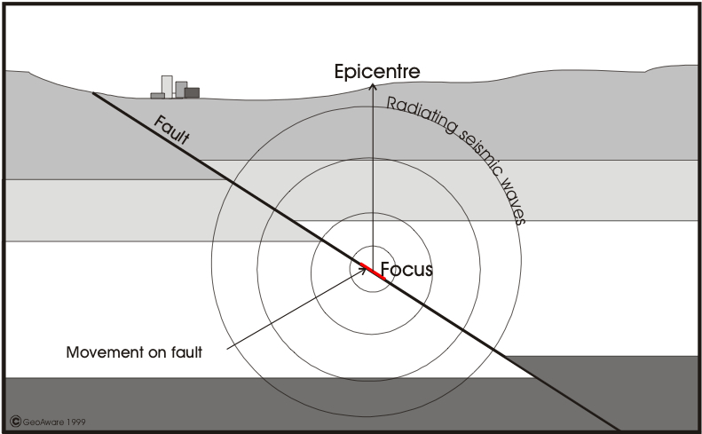
Figure 1 Image courtesy of Mr K Science
What are the two outer layers of the Earth’s upper crust?

What is the epicentre?

How is an earthquake’s energy measured?

What does surface expression mean?

Why does greater surface expression cause larger impacts on land?

List two countries in the world that have examples of fold mountains?
1)
2)
What are the downsides of collisions in fold mountains?

How does the video describe the outer layers of the Earth?

Can earthquakes be predicted? Explain your answer.

List three countries that are constantly on ‘Earthquake watch’
1)
2)
3)
Why does New Zealand have many probabilities/risks for earthquakes?

List three geographical methods that help scientists and geologists predict the probability of an Earthquake or the severity of it
1)
2)
3)
How do aftershocks provide an indicator of the probability of future earthquakes?

List some of the experiences experienced by Christchurch residents.

Why did the Government declare it a national emergency?

How long before had Christchurch experienced an Earthquake?

What was the death toll for the Christchurch earthquake?

What are some of the concerns of rebuilding a city after an earthquake?

What were some personal challenges for residents living in a city after the Christchurch earthquake?

How many aftershocks has Christchurch experienced?

How would aftershocks disrupt daily life?

Write summary points under the following sub headings for the sections

SOCIAL IMPACTS OF EARTHQUAKES

REDUCING RISK
Finish off this statement using evidence from the video and your own opinion. Be sure to back up your opinion.
Earthquakes are very expensive economically and socially because…

