Circle properties

Label the following on the circle below:
Diameter  Radius  Circumference  Area | 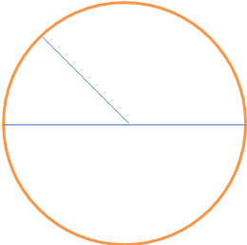

Calculating circle circumference
$$c=2πr$$
Using the above formula, find the circumference of the following circles. Remember to show your working and include the unit value.

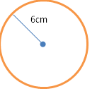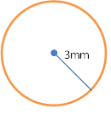
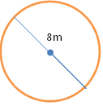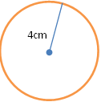

Calculating circle area
$$A=πr^{2}$$
Using the above formula, find the area of the following circles. Remember to show your working and include the unit value.

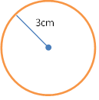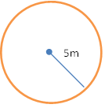

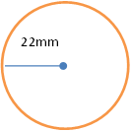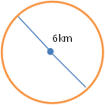

Summary
Using your geometry set, calculate and label this circle’s radius and diameter. Then calculate the circumference and area of the circle.

Radius =
Diameter =
Circumference =
Area =

