- What do Isaac Newton, Gottfried Leibnitz and Usain Bolt have in common?
- What is the central idea of differential calculus?
- (a) Draw a sketch of a graph that represents Usain Bolt’s average speed in his world record run of 9.58s for the 100m.

(b) Calculate his average speed for this race in m/s.
(c) Convert this average speed from m/s to km/h.
- Why is it more realistic for the graph of distance over time to be a curve rather than a straight line? Why does the slope of the curve change?
- How do we get a better and better approximation to the slope of the curve at an instant?

Bolt to the finish!
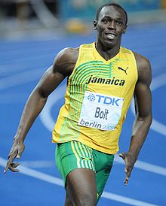
Usain Bolt is an eight-time world and six-time Olympic gold medallist. He won gold in the 100m and 200m in both the 2008 and 2012 Olympics. At the Beijing Olympics in 2008 he ran 9.69s for the 100m and the following year he reduced his world record time for the 100m to 9.58 s.
In the 100m final in the 2008 Olympics, Usain Bolt started celebrating before he finished the race! He let his arms fall down by his side and he beat his chest. And he still won easily! The table below shows Bolt’s times in 10m intervals in this race.
Time (s) | Distance (m)
0 | 0
1.83 | 10
2.87 | 20
3.78 | 30
4.65 | 40
5.5 | 50
6.32 | 60
7.14 | 70
7.96 | 80
8.79 | 90
9.69 | 100

- Enter the data for the run into an Excel spreadsheet and construct a chart showing distance against time.
- Using trendlines in an Excel spreadsheet find a polynomial mathematical model that closely represents Bolt’s run.
- Using your mathematical model from part (b), derive mathematical models that represent Bolt’s velocity and acceleration during his run.
- Draw graphs of distance, velocity and acceleration against time for Bolt’s run.
- Comment on your graphs with reference to the way that Usain Bolt ran the race.
- Once Usain Bolt is up and running
- How fast could he run the length of your classroom?
- How quickly could he run a distance of 50 m?

Teacher notes
Here is some possible analysis work for the investigation.
Time (s) | Distance (m)
0 | 0
2.87 | 10
3.78 | 20
4.65 | 40
5.5 | 50
6.32 | 60
7.14 | 70
7.96 | 80
8.79 | 90
9.69 | 100
Distance v time Velocity v time Acceleration v time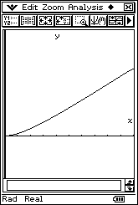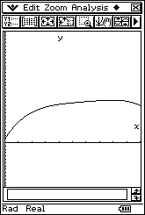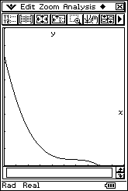
Note the drop in velocity and acceleration at the end of the race.

http://www.youtube.com/watch?v=F14EaVEDyUs
http://www.excel-easy.com/examples/trendline.html

