Use a protractor to measure these angles and say whether they are acute, obtuse or right angles.

TOP TIP: Make sure you line up the cross of the protractor with the corner of the angle.

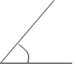 Estimation This angle measures It is acute/obtuse/right
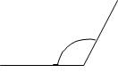 Estimation This angle measures It is acute/obtuse/right
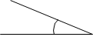 Estimation This angle measures It is acute/obtuse/right
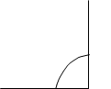 Estimation This angle measures It is acute/obtuse/right

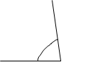 Estimation This angle measures It is acute/obtuse/right
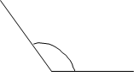 Estimation This angle measures It is acute/obtuse/right
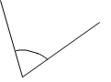 Estimation This angle measures It is acute/obtuse/right
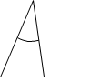 Estimation This angle measures It is acute/obtuse/right
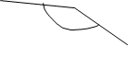 Estimation This angle measures It is acute/obtuse/right

