Captioning with Amara
To begin captioning on Amara, go to the website – https://amara.org/en/ – and create an account. Note that Amara calls captions ‘subtitles’.
On the home page, click on ‘Subtitle a video’ and this page will appear.
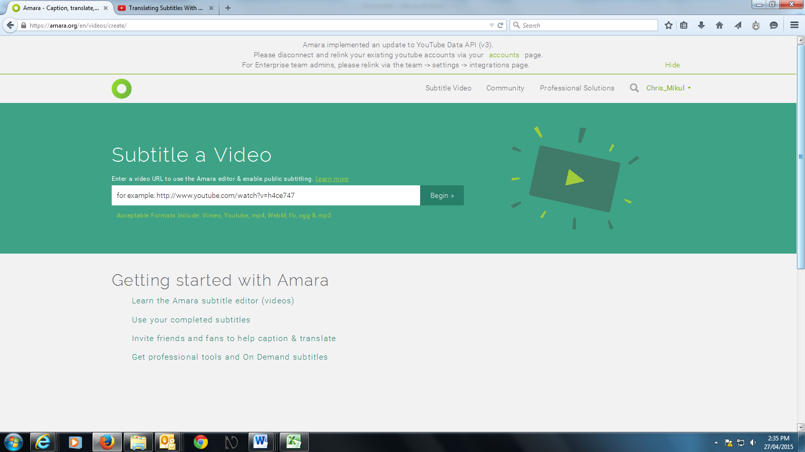
Figure 1 'Subtitle a video' page on Amara

Copy and paste the URL of the video you wish to caption, then click ‘Begin’.
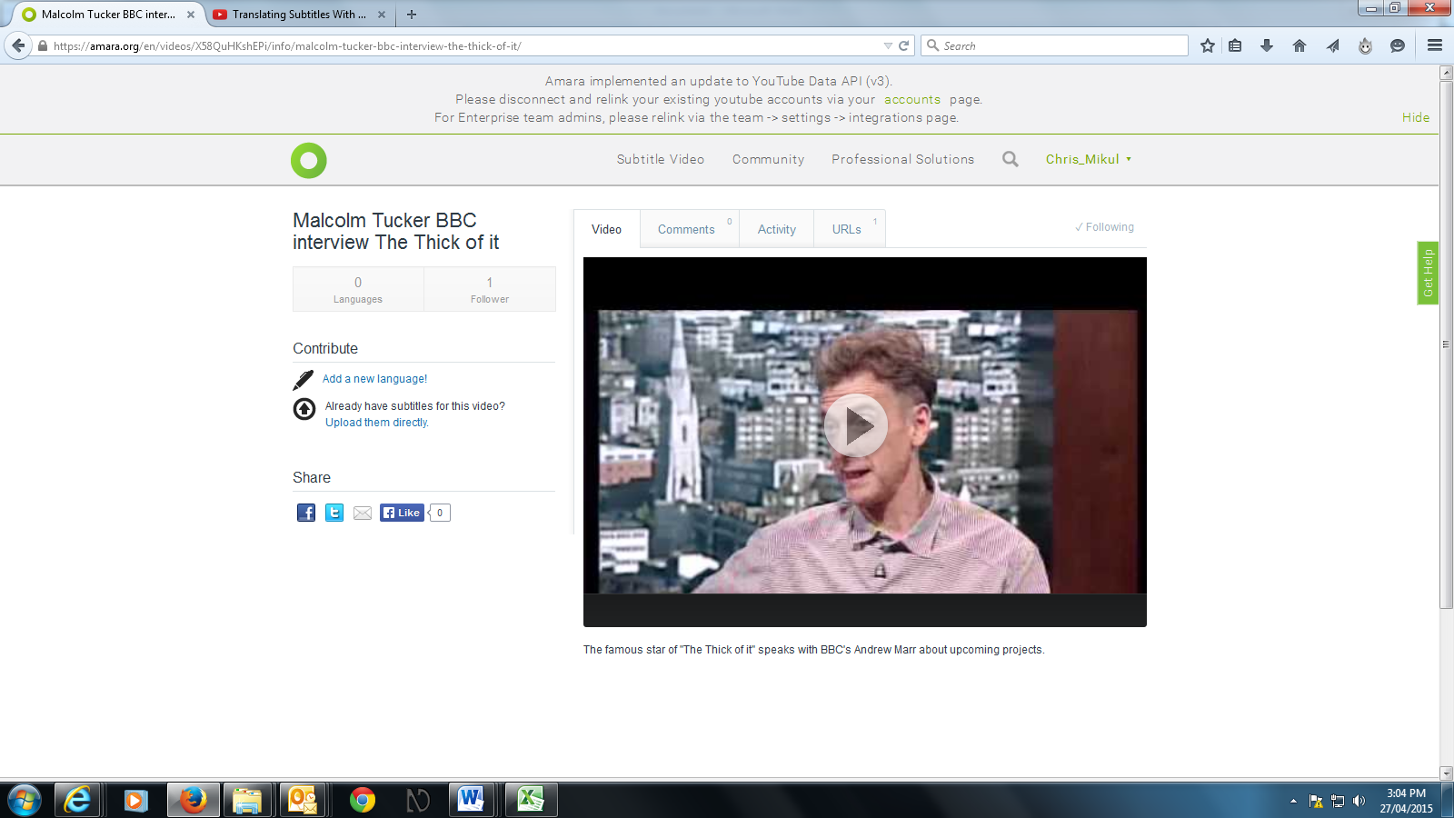
Figure 2 A video loaded onto Amara

To commence captioning, click on ‘Add a new language’ on the left of the screen. You will be asked for the language of the video, and the language of the captions you wish to create. Then click ‘Continue’.

Step 1: Typing

There are three steps to creating captions in Amara: ‘Typing’, ‘Syncing’ and ‘Review and complete’. You will now be at the Typing step, with your video visible in a media player.
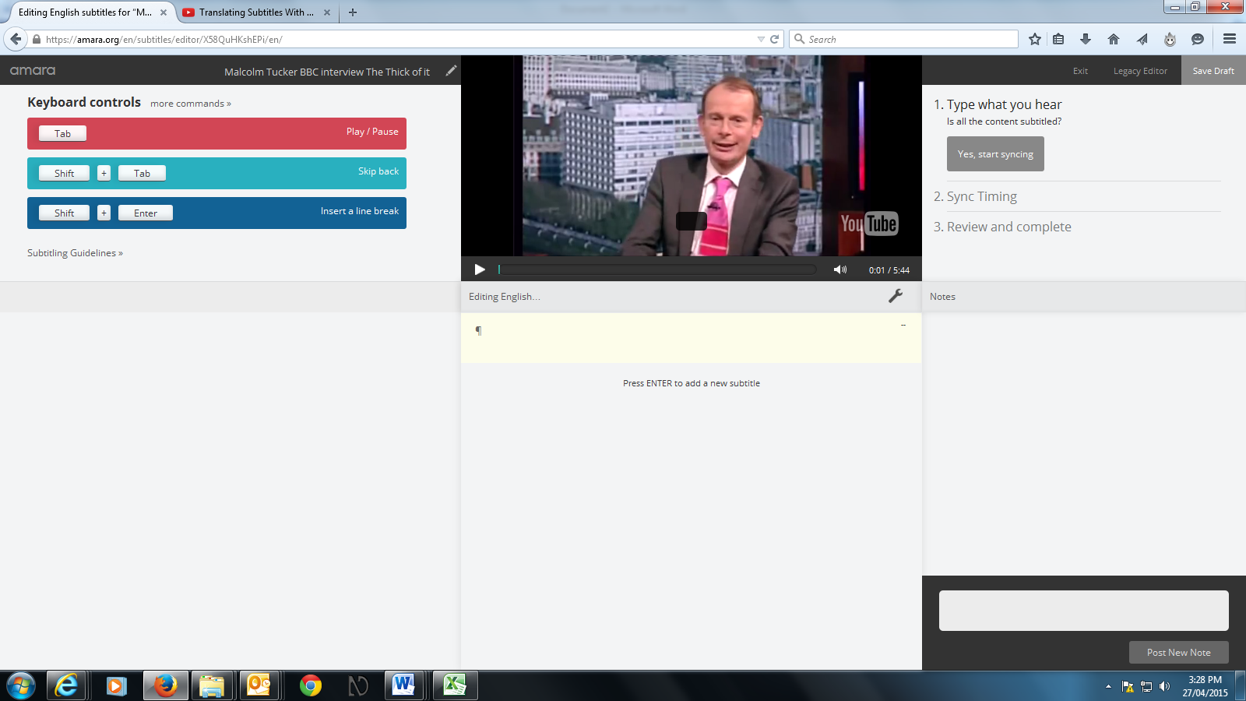
Figure 3 'Typing' page on Amara

Once you are ready to start captioning, play and pause the video as required and type the text for each caption in the box below the video.
The three basic keyboard commands are shown on three bars to the left of the video player. You can execute these commands by pressing the key combinations, or by using your mouse to click on the bar itself.
Pressing ‘shift’ + ‘tab’ will make the video skip back 2 seconds.
Figure 4 keyboard controls on 'Typing' page

Clicking on ‘more commands’ brings up a list of further options, including how to make the video skip back by 4 seconds.

Figure 5 'Keyboard shortcuts' on Amara

After you have typed each sentence (or as much of a sentence as will fit into one caption) press ‘Enter’, which will open up the box for the next caption.

Figure 6 Captions being typed in Amara

If you notice you have made a mistake in a previous caption, you can fix it by clicking on it, then typing the correct text.
When you hover your cursor over a text box with a caption in it, a short tool menu (indicated by a spanner symbol) will appear, giving you the options to add a new caption above or below it, and to delete a caption.
If you have a caption with two lines of text, try to split it so that the lines are of roughly even length. Press ‘shift’ + ‘Enter’ to create a line break, and try to place the break where there is a natural break in the sentence (e.g. where there is a comma).
Don't worry too much about fixing up mistakes during the Typing step, as you can do that in the Syncing and Review steps.
If you need to interrupt your captioning session, click ‘Save draft’ before exiting.
When you have typed all the text of your video, click on ‘Start syncing’.

Step 2: Syncing

The ‘Syncing’ page looks much the same as the ‘Typing’ page, however there are now two additional tasks on the ‘Keyboard controls’: ‘Start subtitle’ and ‘End subtitle’.

Figure 7 Keyboard controls in 'Syncing' step

When you are ready to start synchronising your captions, play the video. When the first caption needs to appear on screen, press the ‘down arrow’ button on your keyboard, creating a caption start point. When the next caption needs to appear, press the ‘down arrow’ again. This will create a start point for the second caption, as well as an end point for the first.
You only need to press the ‘up arrow’ to create an end point for a caption if there is a gap between it and the next caption, or it is the last caption on the video.
Continue until you have synced all the captions for the video. You may need to do this several times to get it right. (You can always start again from scratch by returning to the previous page without saving your work, then forward again to the syncing page.) But don’t worry about making all of the timings exact, as you will be able to fine-tune them in the Review step.
When you’re finished, click on ‘Start review’ for the next step.

Step 3: Review and complete

Play your video once more. If you see any spelling mistakes, or missing dialogue or other audio, pause the video and click on the caption to fix it.
In addition to the captions being superimposed on the video, below the video player you will see them running along a grey line that scrolls continuously as the video plays. A vertical red line runs through the centre of this, indicating how the captions are synced in relation to the video.

Figure 8 Captions playing on Amara

Each caption occupies a separate box, with a tab on either side.

Figure 9 Tabs on each side of an Amara caption
You can change the syncing of a caption by clicking on these tabs, then dragging the edges of the box to the left or right. (Note, you can move the caption line rapidly back and forth by placing your cursor on the row of numbers above it and moving it to the left or right.)
For example, if you have a caption that appears on screen a little late, pause the video at the point where it should appear. Click on the tab at the left hand side of the caption’s box, and drag it to the red vertical line. It will now appear on screen when it should.
You will also need to use this function if there are gaps in the dialogue of your video and you need to create gaps between the captions.
To create a gap between two captions, pause the video at the point where the first caption should end. Click on the arrows to the right of this caption’s box, and drag it to the red line. As you do so, a gap will open between this caption and the following one.
Once you are satisfied that all your captions are correct, you can publish your captions. Before doing this, you may want to click on ‘Edit title and description’. If your video is being hosted in a file sharing service such as YouTube, the information on it will have been automatically imported from there to Amara.
Once the title and description are correct, click on ‘Publish’. The caption file will be integrated with the video, and can now be watched by anyone on the Amara website.

Downloading caption files from Amara

Click on your username on the homepage, select ‘Dashboard’ then ‘My Videos’. This will bring up a list of videos you have loaded to Amara.
Click on the video with the caption file you want to download. This will take you to the video’s homepage.
Under ‘Language’, click on ‘English’.
Click on ‘Download’. A dropdown menu will give you a list of formats you can download your captions in: DFXP, SBV, SRT, SSA, TXT, VTT.
If you wish to upload to YouTube, choose one of the two YouTube-compatible formats, SRT or SBV.
Save the file.

